**Assignment 10.2**

**Question:** Create a sample dataset and implement the below Pig commands on the same dataset.

* Concat
* Tokenize
* Sum
* Min
* Max
* Limit
* Store
* Distinct
* Flatten
* IsEmpty

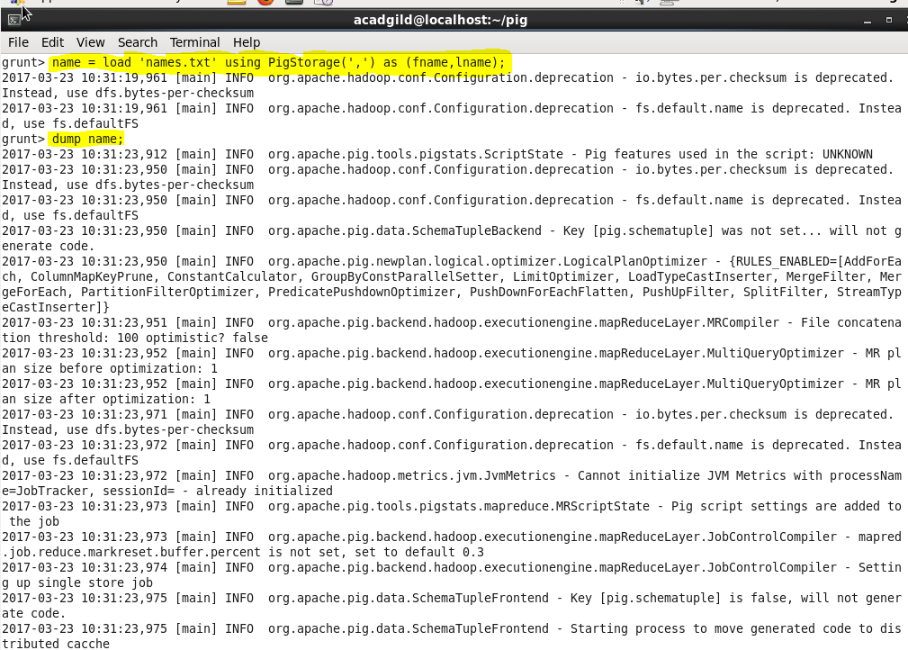

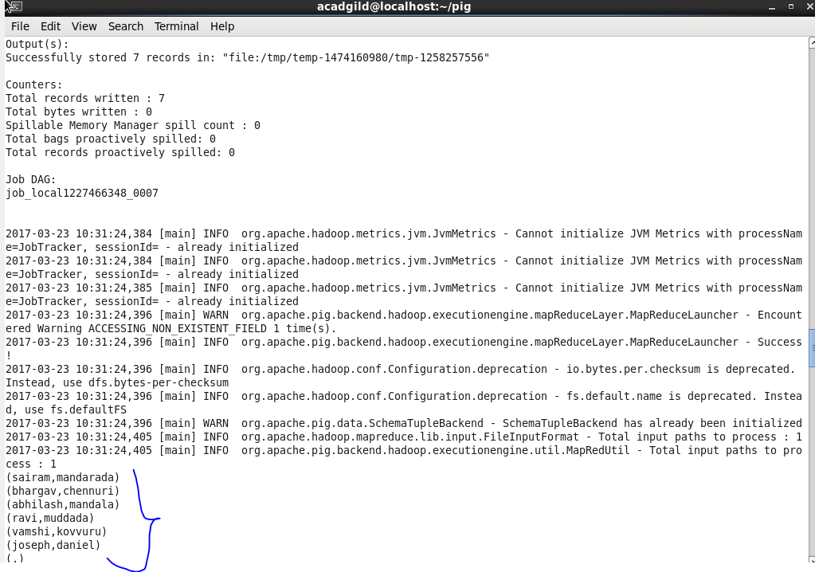

**Concat:**

The *CONCAT()* function of Pig Latin is used to concatenate two or more expressions of the same type.

*Syntax:*

***CONCAT(expression,expression,[expression]);***

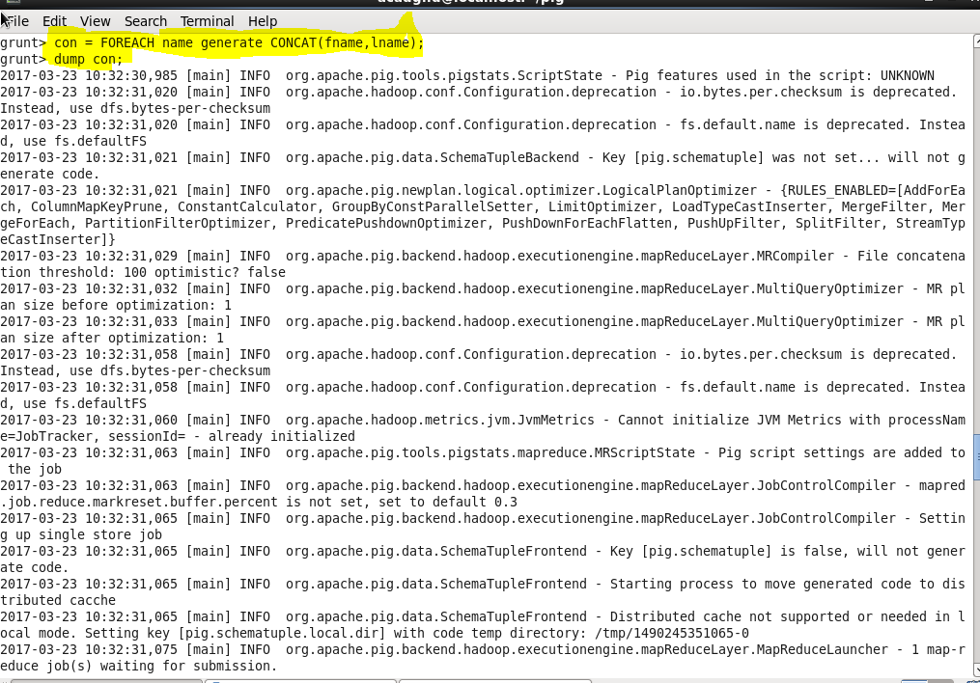

**OUTPUT:**

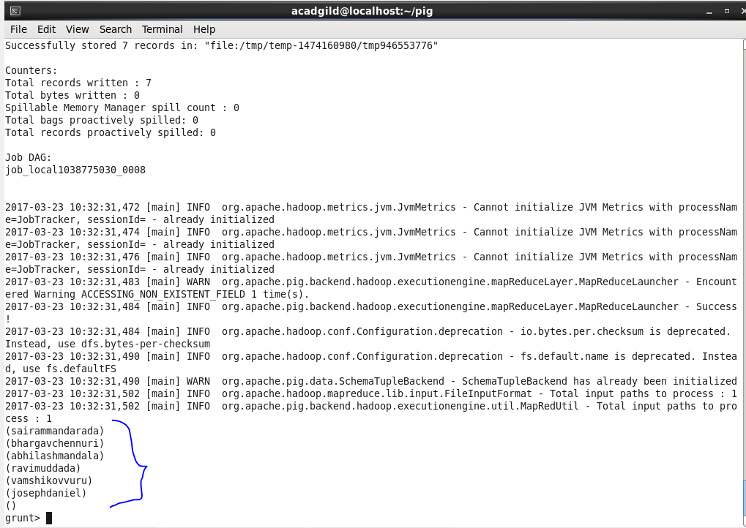

**Tokenize:**

The *TOKENIZE***()** function of Pig Latin is used to split a string (which contains a group of words) in a single tuple and returns a bag which contains the output of the split operation.

*Syntax:*

***TOKENIZE(expression,[field_delimiter’]);***

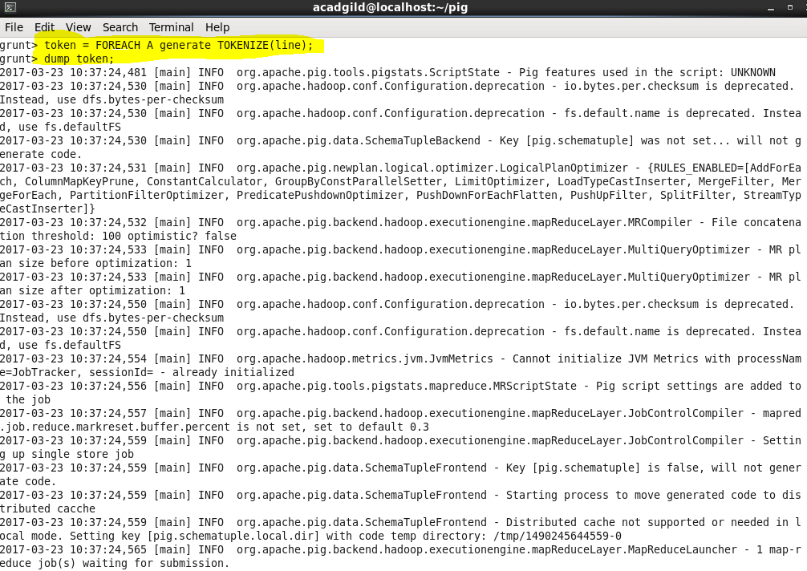

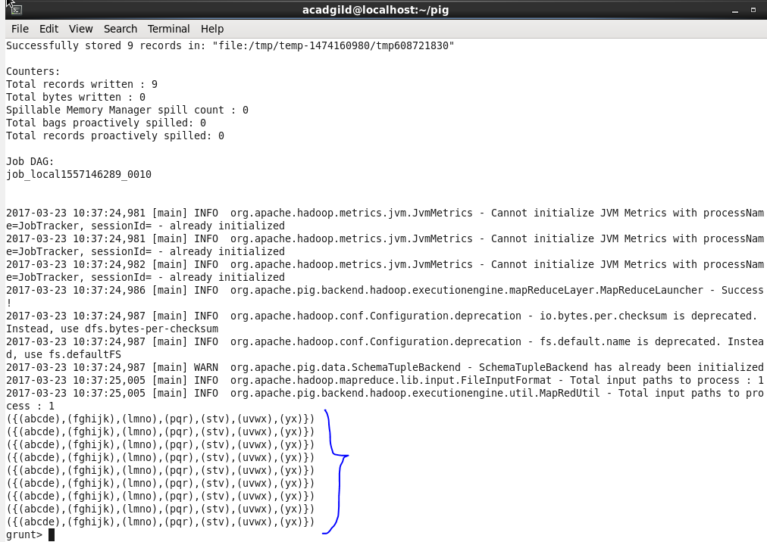

**Sum*:***

We can use the *SUM()* function of Pig Latin to get the total of the numeric values of a column in a single-column bag. While computing the total, the *SUM()* function ignores the NULL values.

*Syntax***:**

**SUM(expression);**

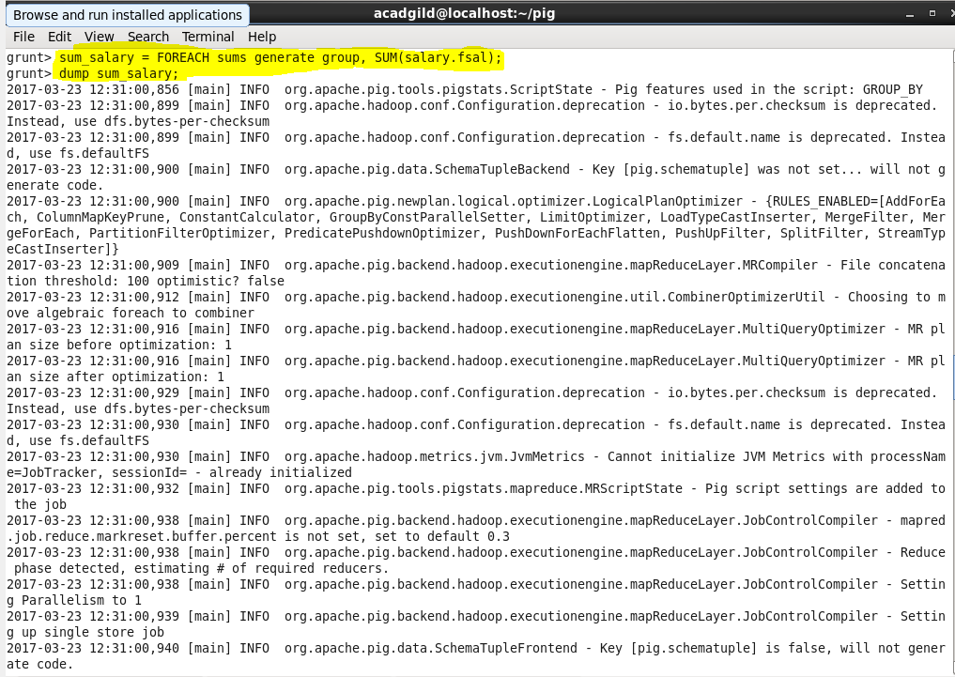

**OUTPUT:**

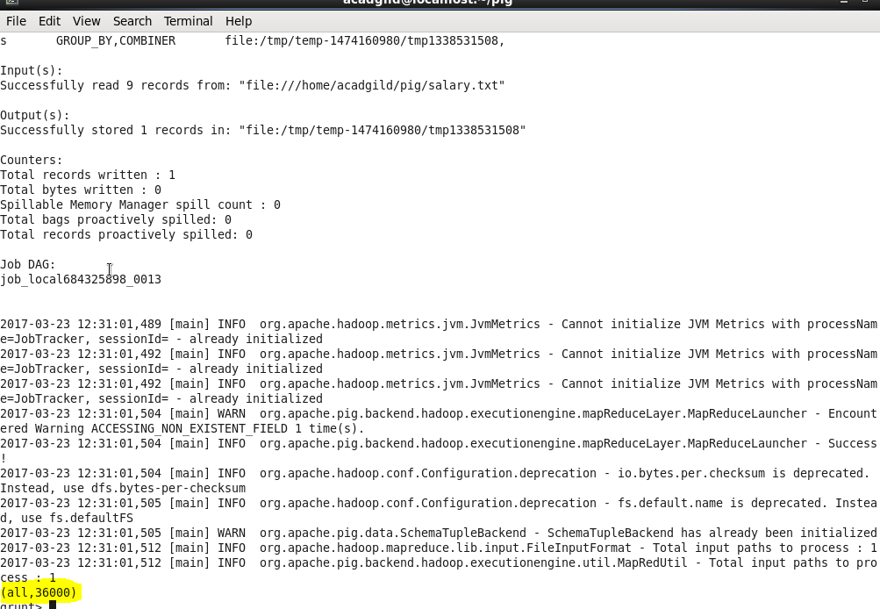

**Min:**

The *MIN()* function of Pig Latin is used to get the minimum (lowest) value (numeric or chararray) for a certain column in a single-column bag. While calculating the minimum value, the *MIN()* function ignores the NULL values.

*Syntax***:**

**MIN(expression);   
  
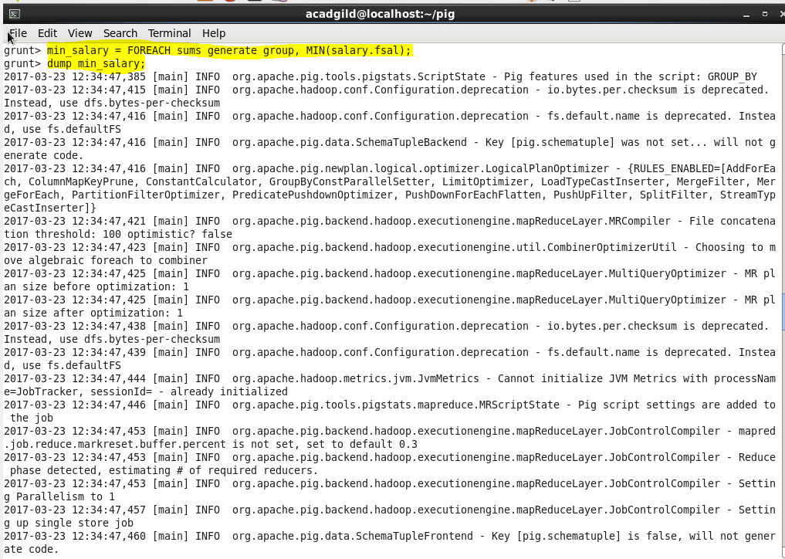**

**OUTPUT:**

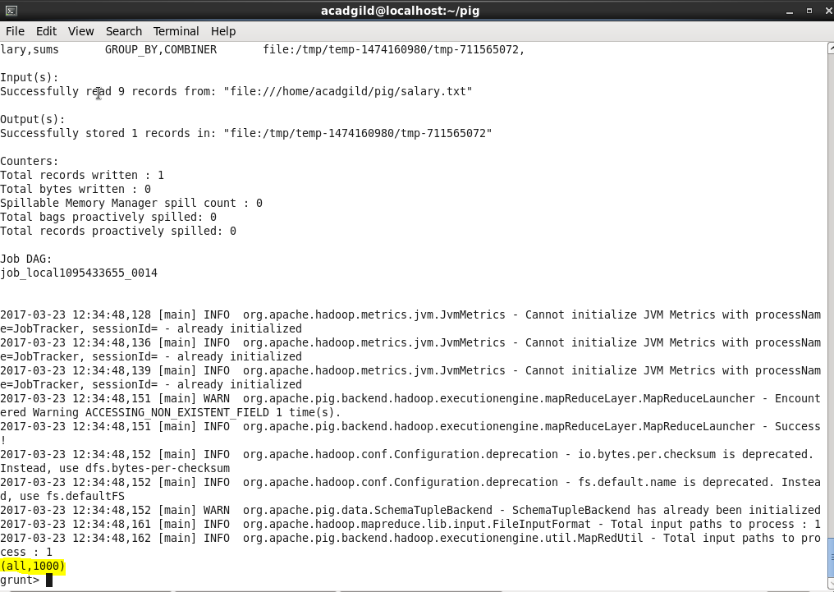

**Max:**

The Pig Latin *MAX()* function is used to calculate the highest value for a column (numeric values or chararrays) in a single-column bag. While calculating the maximum value, the *Max()* function ignores the NULL values.

***Syntax*:**

**MAX(expression);**

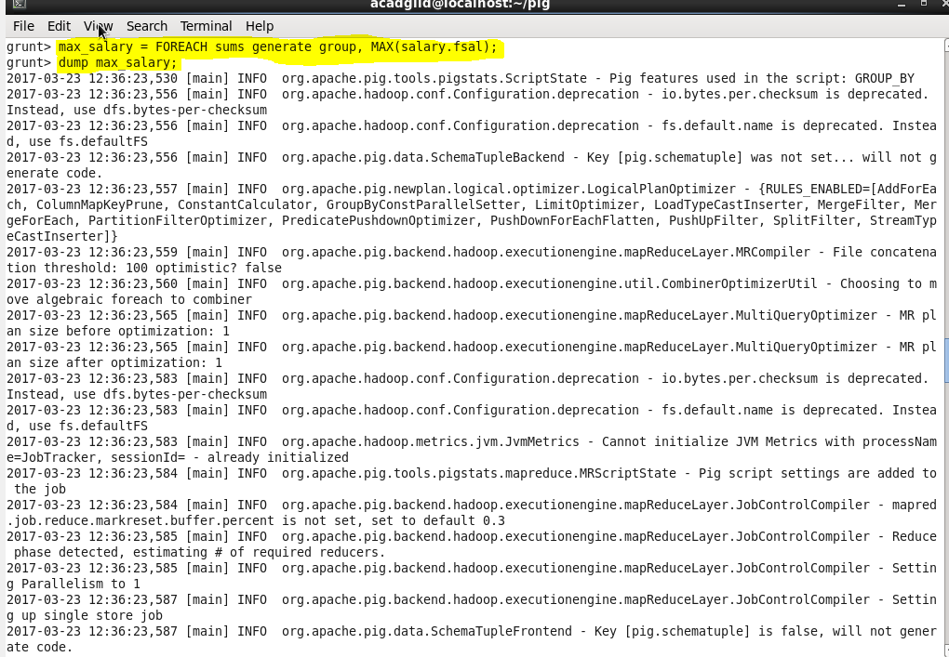

**OUTPUT:**

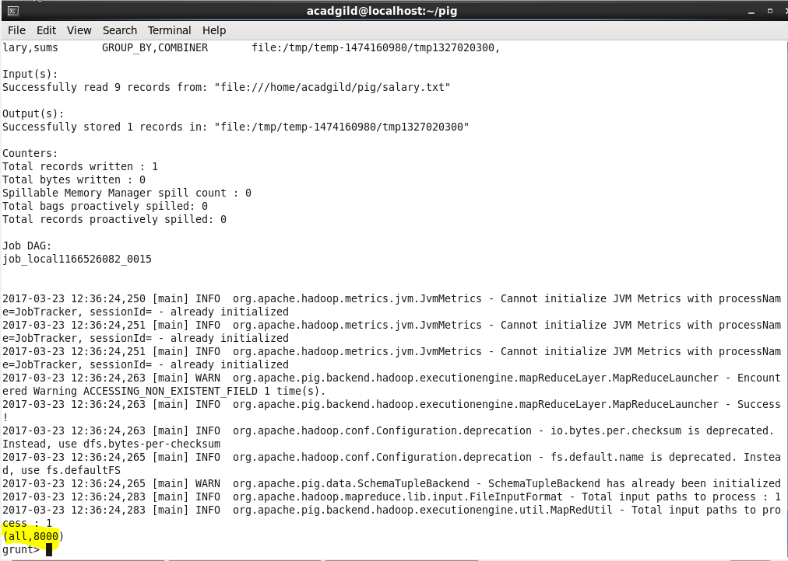

**Limit:**

Used to limit the number of outputs to the desired number.

*Syntax*:

***Relation_name2 = LIMIT Relation_name1 n;***

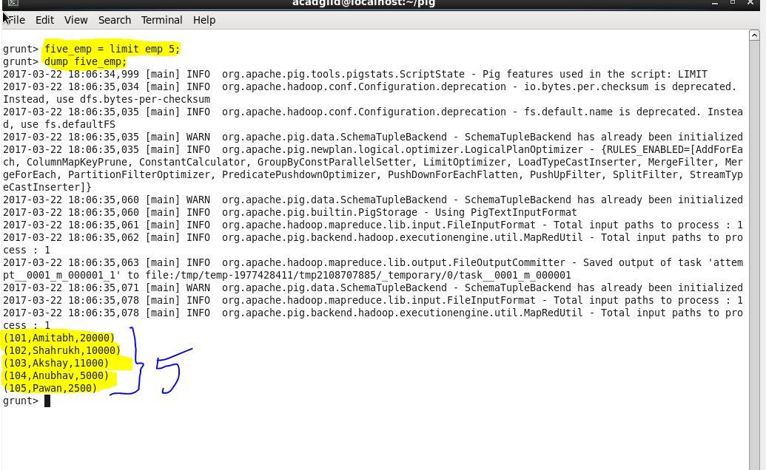

**STORE:**

We can store the loaded data in the file system using the *store* operator.  
*Syntax***:**

***STORE Relation_name INTO ‘required_directory_path’ [USING Function];***

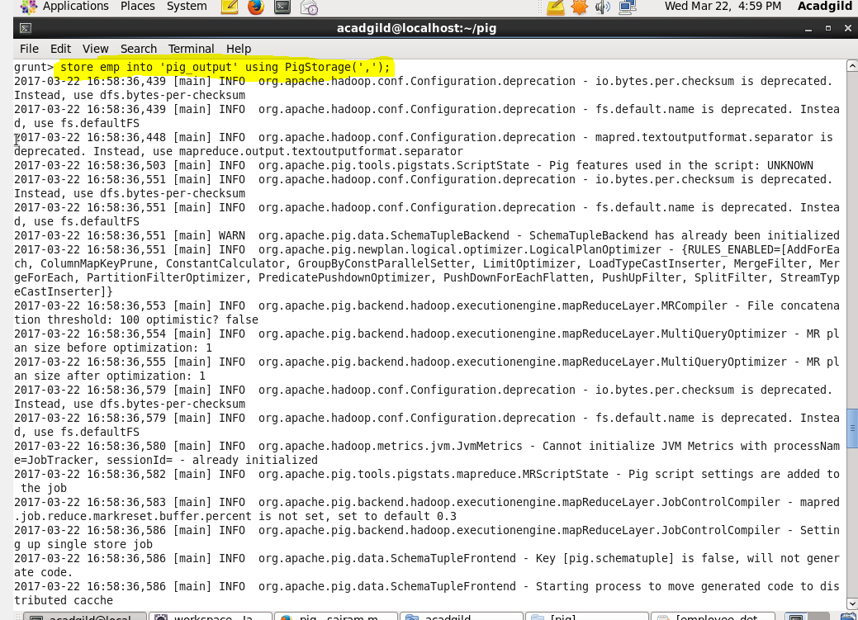

**OUTPUT:**

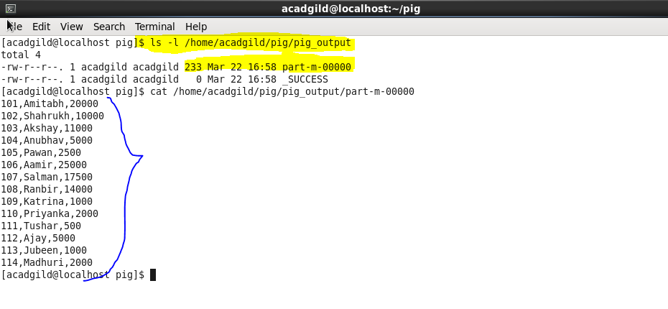

**Distinct:**

The *DISTINCT* operator is used to remove redundant (duplicate) tuples from a relation.

*Syntax:*

***Relation_name2 = DISTINCT Relation_name1;***

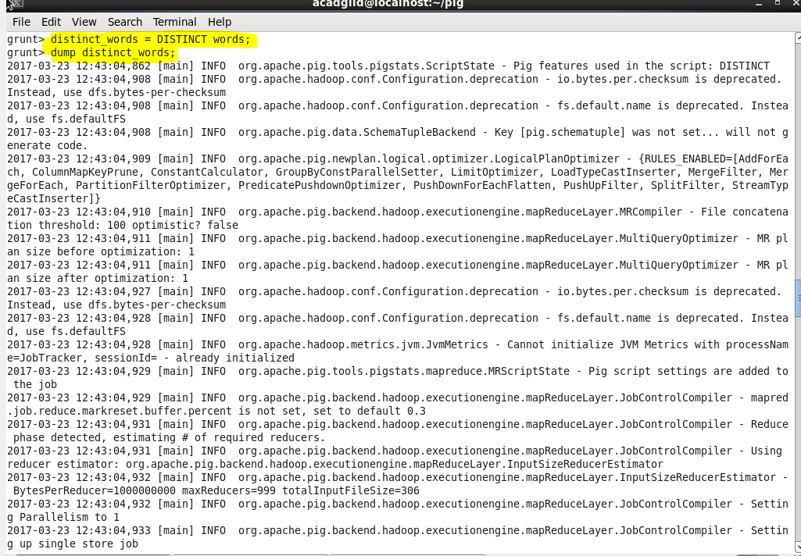

**OUTPUT:**

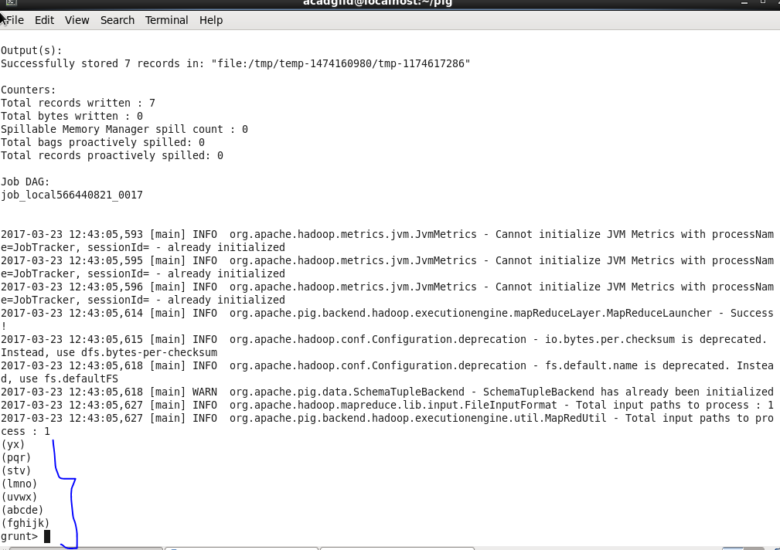

**Flatten:***FLATTEN* is an expression which will eliminate a level of nesting. Given a tuple which contains a bag, *FLATTEN* will emit several tuples each of which contains one record from the bag.

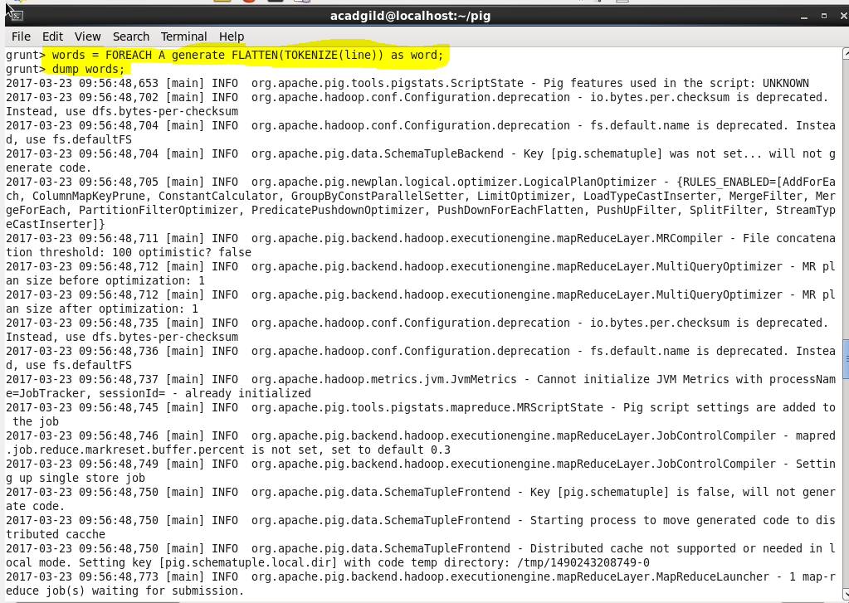 **OUTPUT:**

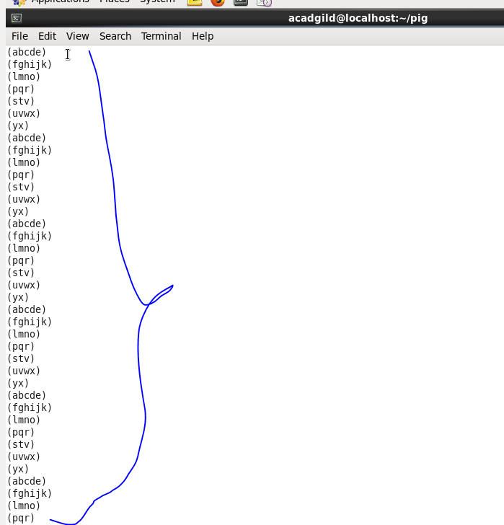

**IsEmpty:**

The *IsEmpty()* function of Pig Latin is used to check if a bag or map is empty.

*Syntax:*

***IsEmpty(expression);***

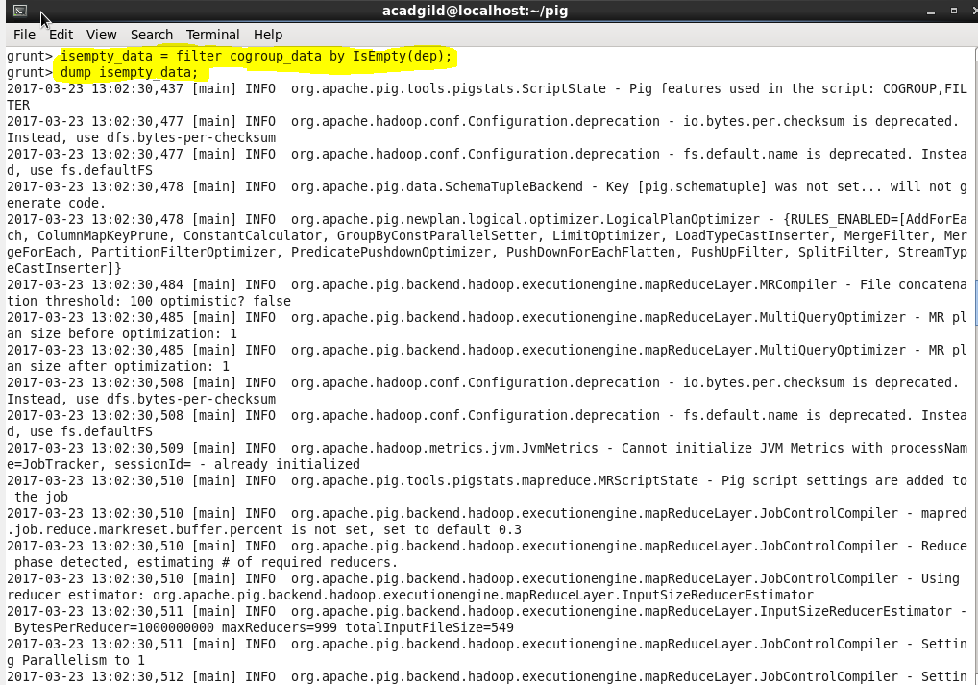

**Output:**

